### Semester One Examination, 2016

### Question/Answer Booklet

# MATHEMATICS

If required by your examination administrator, please place your student identification label in this box

**SPECIALIST**

**UNIT 1**

## Section Two:

## Calculator-assumed

|  |  |  |  |  |  |  |  |  |
| --- | --- | --- | --- | --- | --- | --- | --- | --- |
| Student Number: In figures |  |  |  |  |  |  |  |  |

In words

Your name

## Time allowed for this section

Reading time before commencing work: ten minutes

Working time for section: one hundred minutes

## Materials required/recommended for this section

***To be provided by the supervisor***

This Question/Answer Booklet

Formula Sheet (retained from Section One)

***To be provided by the candidate***

Standard items: pens (blue/black preferred), pencils (including coloured), sharpener, correction fluid/tape, eraser, ruler, highlighters

Special items: drawing instruments, templates, notes on two unfolded sheets of A4 paper, and up to three calculators approved for use in the WACE examinations

## Important note to candidates

No other items may be taken into the examination room. It is **your** responsibility to ensure that you do not have any unauthorised notes or other items of a non-personal nature in the examination room. If you have any unauthorised material with you, hand it to the supervisor **before** reading any further.

## Structure of this paper

|  |  |  |  |  |  |
| --- | --- | --- | --- | --- | --- |
| Section | Number of questions available | Number of questions to be answered | Working  time (minutes) | Marks available | Percentage of exam |
| Section One:  Calculator-free | 7 | 7 | 50 | 49 | 35 |
| Section Two:  Calculator-assumed | 13 | 13 | 100 | 102 | 65 |
|  | | | **Total** | 151 | 100 |

## Instructions to candidates

1. The rules for the conduct of examinations are detailed in the school handbook. Sitting this examination implies that you agree to abide by these rules.
2. Write your answers in this Question/Answer Booklet.
3. You must be careful to confine your response to the specific question asked and to follow any instructions that are specified to a particular question.
4. Spare pages are included at the end of this booklet. They can be used for planning your responses and/or as additional space if required to continue an answer.

* Planning: If you use the spare pages for planning, indicate this clearly at the top of the page.
* Continuing an answer: If you need to use the space to continue an answer, indicate in the original answer space where the answer is continued, i.e. give the page number. Fill in the number of the question that you are continuing to answer at the top of the page.

1. **Show all your working clearly**. Your working should be in sufficient detail to allow your answers to be checked readily and for marks to be awarded for reasoning. Incorrect answers given without supporting reasoning cannot be allocated any marks. For any question or part question worth more than two marks, valid working or justification is required to receive full marks. If you repeat any question, ensure that you cancel the answer you do not wish to have marked.
2. It is recommended that you **do not use pencil**, except in diagrams.
3. The Formula Sheet is **not** to be handed in with your Question/Answer Booklet.

Section Two: Calculator-assumed 65% (102 Marks)

This section has**thirteen (****13)** questions. Answer **all** questions. Write your answers in the spaces provided.

Working time for this section is 100 minutes.

Question 8 (5 marks)

In the diagram below, AB is a tangent to the circle and .

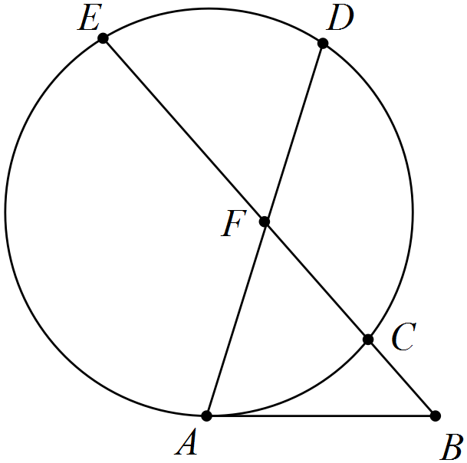

If  and , determine the lengths of

(a) AB. (2 marks)

(b) CF. (1 mark)

(c) AF. (2 marks)

Question 9 (7 marks)

Two forces act on body. The first has magnitude 250 N and acts in direction 240° and the second has magnitude 410 N and acts in direction 170°.

(a) Determine the resultant of the two forces. (4 marks)

(b) The work done, in joules, by a force in moving a body is the scalar product of the force, in newtons, and the displacement, in metres. Determine the total work done by the two forces, to the nearest 100 joules, if the body moves 45 metres in direction 215°. (3 marks)

Question 10 (8 marks)

(a) Use a counterexample to demonstrate that each of following statements are false.

(i) . (2 marks)

(ii) If, then  is always prime. (2 marks)

(b) The statement 'if a natural number is a multiple of 4 and 5 then the natural number is a multiple of 20' is true.

(i) Write the contrapositive of the statement and explain whether or not the contrapositive is also true. (2 marks)

(ii) Write the converse of the statement and explain whether or not the converse is also true. (2 marks)

Question 11 (8 marks)

Fifteen children at a summer camp are to be divided into two groups of nine and six.

(a) Determine the number of different groupings. (2 marks)

(b) Determine how many groupings are possible if the two youngest children must be in the same group. (3 marks)

(c) If ten of the fifteen were girls, in how many of the different groupings do both groups contain more girls than boys? (3 marks)

Question 12 (7 marks)

Vector a has magnitude 6 units and acts on a bearing of 310°. Vector b has magnitude 12 units and acts on a bearing of 070°.

(a) Determine the magnitude and direction of . (4 marks)

(b) Determine the value of the constant k if the direction of  is due north. (3 marks)

Question 13 (9 marks)

(a) AB is a diameter of a circle centre O. C is a point on the circumference. D is a point on AC such that OD bisects . Prove that OD is parallel to BC. (4 marks)

(b) In the diagram below, FCG is a tangent to the circle ABC. BD bisects , CD bisects , BE bisects  and CE bisects . If  and , determine the ratio, in simplest form, of . (5 marks)

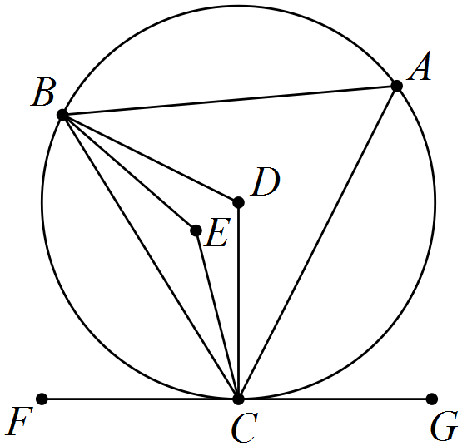

Question 14 (9 marks)

Points O, P, Q and R have position vectors , ,  and .

(a) Determine the value of y if . (2 marks)

(b) Determine the value of x if $\vec{OQ}$ $\vec{QR}$. (3 marks)

(c) Determine the values of x and y if R lies on the line between P and Q such that . (4 marks)

Question 15 (9 marks)

(a) ABCDEF is a regular hexagon in which $\vec{BC}$ represents b and $\vec{FC}$ represents 2a.

Express the vectors $\vec{CD}$, $\vec{EA}$ and $\vec{BE}$ in terms of a and b. (3 marks)

(b) Given c and d are vectors such that ,  and the angle between their directions is 40°, determine

(i) . (3 marks)

(ii) the angle between d and . (3 marks)

Question 16 (10 marks)

(a) If a room contains 75 adults, use the pigeonhole principle to explain why a group containing at least 11 of these people could be chosen so that all were born on the same day of the week. (3 marks)

(b) Twelve senior students each brought at least one toy to school to donate to the pre-primary centre. Given that a total of 75 toys were donated, prove that at least two of the senior students brought in the same number of toys.

*Hint: Think of a contradiction.* (3 marks)

(c) Determine how many numbers between 1 and 150 inclusive are multiples of 3, 4 or 5.

(4 marks)

Question 17 (8 marks)

A boat with a constant speed of 6 ms-1 is required to leave its mooring and motor directly to a jetty located 1 045 metres away on a bearing of 155°. A current of 1.5 ms-1 is running on a bearing of 200°.

(a) Sketch a diagram to that can be used to determine the direction the boat should steer.

(2 marks)

(b) Determine the bearing that the boat should steer. (3 marks)

(c) Determine the time taken for the boat to reach the jetty. (3 marks)

Question 18 (7 marks)

(a) Let ,  and .

Prove that the scalar product is distributive over vector addition: .

(4 marks)

(b) Given  and ,

determine . (3 marks)

Question 19 (8 marks)

(a) Determine the number of ways that ten different coloured cubes can be placed in a line.

(1 mark)

(b) Determine the number of ways that six different coloured cubes can be placed in a line if the blue, red and green cubes must be together. (2 marks)

(c) Eight identical cubes, coloured red, red, red, blue, blue, green, orange and yellow, are arranged in a line.

(i) Determine the number of arrangements in which the red cubes are all adjacent.

(2 marks)

(ii) Determine the number of arrangements in which no two red cubes are adjacent.

(3 marks)

Question 20 (7 marks)

The diagram shows three semicircles with diameters AD, AB and BD, where B is a point on the diameter AD. Point C is the centre of the semicircle with diameter BD. Line BE is perpendicular to diameter AD and meets the largest semicircle at E. Points F and H are the intersections of lines AE and DE with the smaller semicircles. Point G is the intersection of lines FH and BE.

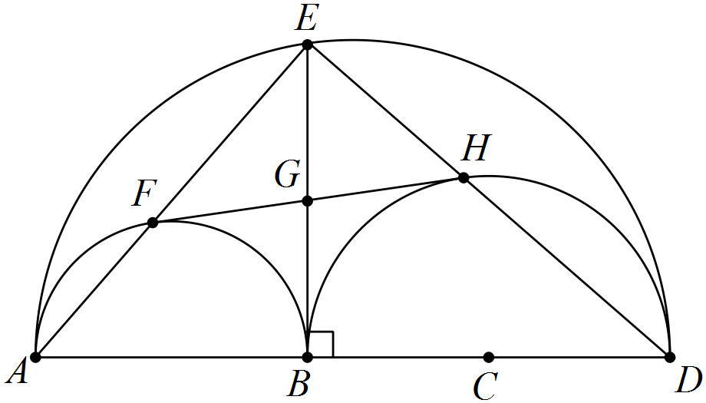

(a) Explain why BFEH is a rectangle. (2 marks)

(b) Prove that  and  are congruent. (3 marks)

(c) Deduce that line FH is a tangent to the semicircle with diameter BD. (2 marks)

Additional working space

Question number: _________

Additional working space

Question number: _________

© 2016 WA Exam Papers. Rossmoyne Senior High School has a non-exclusive licence to copy and communicate this paper for non-commercial, educational use within the school. No other copying, communication or use is permitted without the express written permission of WA Exam Papers.